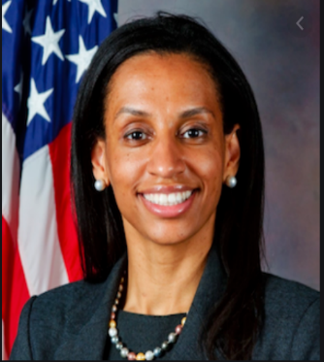
Donna S. Bennett
Enterprise Chief Information Security Officer
Bureau of Information Resource Management
U.S Department of State

Donna Bennett was recently named Enterprise Chief Information Security Officer for the U.S. Department of State. She is the former Deputy Chief Information Security Officer (CISO) at the U.S. Department of Commerce and former CISO at the Federal Emergency Management Agency (FEMA), responsible for the unprecedented Identity Credential and Access Management (ICAM) integration of Personal Identity Verification smart cards for the Single Sign-On (SSO) access of all assets include derive credential within the FEMA Enterprise Network (FEN).
As a security industry veteran, Ms. Bennett brings over 25 years of experience leading large enterprise information security architecture, policy, operations, and modernization. Prior to 2014, Ms. Bennett served in various cyber security leadership positions throughout the Department of Defense, to include the Department of Navy. Following her distinguished U.S. Naval service, she worked in industry as an Enterprise Network Architect, refurbishing networks while ships were awaiting their next deployment cycle.
Ms. Bennett managed Cyber Security of the Unified Atlantic Region Network Operations Center at Naval Computer and Telecommunications Area Master Station Atlantic. She was the Senior Information Assurance Officer for U.S. Naval Forces Europe/ U.S. 6th Fleet supporting two combatant commands: United States European Command (EUCOM) (51 countries and territories) and United States African Command (AFRICOM) (53 African Nations) in planning and implementing the security of applications and networks in support of several Maritime Domain Awareness Programs
Ms. Bennett holds a Bachelor's degree in Computer Information Systems from Saint Leo University and Master of Science Degree in Information Assurance from Norwich University (NSA Center of Excellence). She is a graduate of the Harvard Kennedy School Senior Executive Fellows, Executive Service Development Seminar, and holds various Technical and Cyber Security certifications. Her awards include the National Security Agency's Frank B. Rowlett Award, Joint Civilian Service Commendation, Civilian of the Year, the Federal 100 (2017), Fed Scoop Top 50 Women in IT (2016 and 2017), and GCN DIG IT Award for Cyber Security (2016 and 2017). In addition to her professional work, she serves as an Adjunct Professor at University of Maryland University College (UMUC) where she teaches Cybersecurity Management, Policy and Information Technology.

