Ramona E. Watts-Sutton

Chief of the Contracting Office

U.S. Customs and Border Protection
Department of Homeland Security
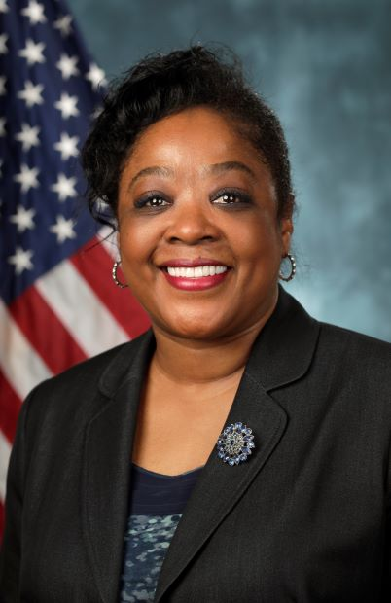

Ramona E. Watts-Sutton serves as the Chief of the Contracting Office for the Procurement Directorate, Office of Acquisition, U.S. Customs and Border Patrol (CBP) Department of Homeland Security, managing day-to-day contract operations for CBP. Prior to coming to CBP, she served as the Aviation and C4ISR Systems Contracts Division Chief for the U.S. Coast Guard’s Acquisition Directorate, where she managed the $30B portfolio of recapitalization Aviation projects and the $5B portfolio for C4ISR projects.

Ms. Watts-Sutton began her civil service career as a Contract Specialist with the Department of Defense’s Naval Air Systems Command (NAVAIR). During her tenure there, she supported the Naval Air Warfare Center – Aircraft Division’s Contracted Support Services Department, and NAVAIR’s Air, Anti-Submarine Warfare, Assault and Special Mission Contracts Department. Some of these projects included the Marine Corps’ AV-8B Harrier Program, the H-1 Utility/Attack Helicopter Programs, MH-60 platforms, and the V-22 Osprey Program. Subsequently, Ms. Watts-Sutton served as the Division Head, Guidance/Test Instrumentation/Systems Group, Strategic Systems Programs. As the Supervisory Contracting Officer, she was responsible for highly specialized acquisitions of national significance in support of the Navy’s Fleet Ballistic Missile (FBM) weapon system.

Ms. Watts-Sutton graduated Summa Cum Laude, earning a Bachelor of Arts degree in Sociology from Fayetteville State University and a Master of Business Administration with a concentration in Organizational Leadership from the University of Baltimore. She is a graduate of the NAVAIR Leadership Development Program and a member of the DHS Acquisition Professional Community.

