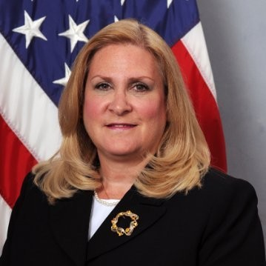

Ms. Ragucci assumed her current Senior Executive Service duties as Director for the U.S. Department of Treasury, Office of Small and Disadvantaged Business Utilization (OSDBU) in March 2018. She is responsible for Small Business Programs that include mission, compliance, outreach, and training for a 10,000 member organization obligating over $6.7 billion annually. Her office assists the Department of the Treasury’s Senior Procurement Executive with exceeding the Department of Treasury’s small business targeted goals, while ensuring compliance with the federally directed Category Management Initiative and meeting the Small Business Administration statutory socio-economic small business goals. Ms. Ragucci aligns best business practices with other OSDBUs throughout the federal government and writing collaborative small business policy through the Office of Federal Procurement and Policy and Office of Management and Budget. In her tenure, her office received national recognition from the Service Disabled Veteran Owned Small Business Association and the National HUBZone Association. Her office is a Core Cluster member of the White House Initiatives Group on HBCUs, championing the awareness of and increasing federal contracting opportunities for HBCUs and the underserved.

