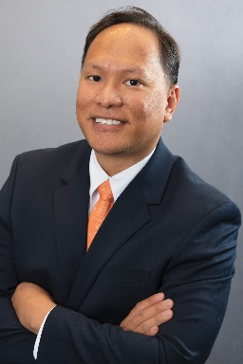
Ronie M. Namata
Contracting Officer, U.S. Customs and Border Protection
Ronie M. Namata is has been in procurement field for close to twenty years. Prior to joining U.S. Customs and Border Protection (CBP), Mr. Namata worked at Science Applications International Corporation (SAIC).
Mr. Namata currently supports the Office of Finance and the Office of Facilities and Asset Management. He is a member of the CBP Procurement Innovation Team (PIT) and the Team Lead for CBP’s Procurement Directorate (PD) Robotics Process Automation (RPA) Bot Team and has designed, developed, and maintained robots that performs tasks normally performed by procurement personnel such as de-obligation modifications and communications, award executions, and contract file automations.
Mr. Namata is a native speaker of the Cebuano dialect. He graduated from the University of Maryland at College Park with a B.A. in Economics

