MICHAEL C. AMARAL
CHIEF, STRATEGIC PROGRAMS BRANCH
CONTRACT SUPPORT AND STRATEGIC PROGRAMS DIVISION
OFFICE OF ACQUISITION, PROCUREMENT DIRECTORATE
U.S. CUSTOMS AND BORDER PROTECTION (CBP)
DEPARTMENT OF HOMELAND SECURITY (DHS)

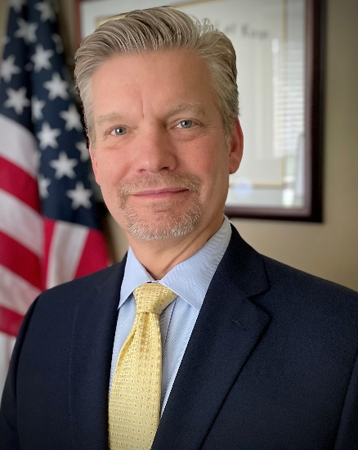
Michael C. Amaral is the Branch Chief for the Strategic Programs Branch in the Contract Support and Strategic Programs Division within the Office of Acquisition’s Procurement Directorate (PD) of U.S. Customs and Border Protection (CBP). He is currently assigned to PD’s office located in Indianapolis, Indiana.
Mr. Amaral is part of a team that is responsible for managing procurement programs, policies, and procedures for CBP. He oversees staff that provides direct and indirect support to the Head of the Contracting Activity office and to CBP’s five operational procurement divisions. In his current role, Mr. Amaral manages the audit and oversight function of PD’s procurement program; provides all operational and strategic reporting for PD; manages systems access and provides real-time systems support to staff for all acquisition-related systems and applications; and oversees CBP’s Government Purchase Card program. Additionally, Mr. Amaral is currently the Office of Acquisition’s representative on CBP’s Initial Assessment Team supporting the Department’s participation on the Committee on Foreign Investment in the United States (CFIUS), an interagency committee that reviews mergers, acquisitions, or takeovers that could result in foreign control of a U.S. business enterprise.
Mr. Amaral served twenty-eight years in the United States Navy as a Reserve Intelligence Officer. Prior to joining CBP, he worked for SAIC as the Director, Homeland Security Analysis Programs in the Thomas Business Unit in Sterling, VA.
Mr. Amaral has a Juris Doctor degree from New England School of Law and is a member in good standing of the Massachusetts Bar Association. He also holds a B.A. in Political Science and International Relations from Boston University.

