Carla L. Provost, National Chief (retired), U.S. Border Patrol

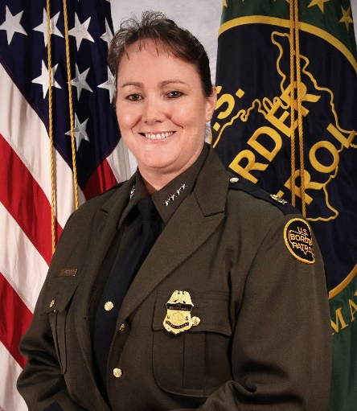
Ms. Provost served as Chief, U.S. Border Patrol from August 2018 through January 2020. She retired from federal service after 25 years in the U.S. Border Patrol on January 30th, 2020.

Chief Provost entered on duty with the U.S. Border Patrol on January 8, 1995, as a member of Class 277. She was first assigned as a Border Patrol Agent at the Douglas Station in the Tucson Sector, subsequently promoted to Supervisory Border Patrol Agent in 1998, and to Field Operations Supervisor in 2001. In 2006, Chief Provost transferred to the Yuma Sector as an Assistant Chief Patrol Agent. In 2009, she became the Patrol Agent in Charge of the Wellton Station in the Yuma Sector, and in 2011, she was appointed to the SES as Deputy Chief Patrol Agent of the El Paso Sector. In 2013, she became the Chief Patrol Agent of the El Centro Sector, in Imperial, California, where she led 1,200 employees and oversaw all operations within her area of responsibility. In 2015, Chief Provost was selected as the Deputy Assistant Commissioner for CBP’s Office of Professional Responsibility, where she oversaw internal investigations and allegations of misconduct for CBP’s workforce of 60,000. She was selected as Deputy Chief of the U.S. Border Patrol in October of 2016. In April of 2017, she became the Acting Chief, U.S. Border Patrol. She remained in that role until her selection as Chief in August of 2018.

Throughout her career, Chief Provost was an avid supporter of the frontline men and women in the Border Patrol, while upholding the Border Patrol motto of “Honor First.” Among Chief Provost’s many accomplishments in her distinguished career, is her successful standup of CBP’s Law Enforcement Officer/Agent Safety and Compliance Directorate (LESC), which is responsible for the development and articulation of all CBP use of force policies and provides the agency with comprehensive and operational Use of Force programs and training. Chief Provost spent her career promoting continual learning and served as an instructor for bike patrol units, firearms training, and post-academy law as a young field Agent. Her operational experience spans across four different Sectors inclusive of all four states that border Mexico.
Prior to joining the U.S. Border Patrol, Chief Provost served for 2 1/2 years as a Police Officer with the Riley County Police Department in Manhattan, Kansas. She earned a Master of Science degree in National Resource Strategy from the Industrial College of the Armed Forces at the National Defense University in Washington, D.C., and a Bachelor of Science degree in Sociology/Criminal Justice from Kansas State University. She is also a 2018 Presidential Meritorious Rank Award Recipient.

