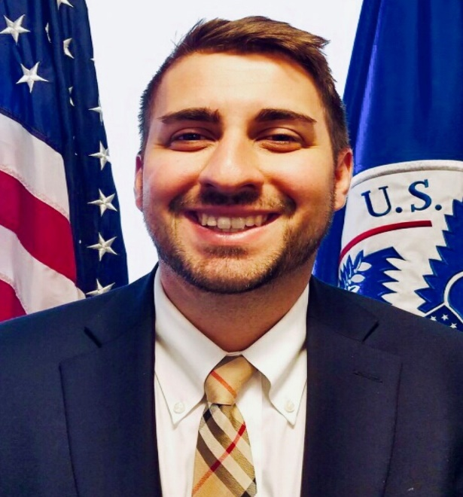

Peter Giambone currently is a Contracting Officer for the Mission Support Contracting Division (MSCD), for U.S. Customs and Border Protection (CBP); where his focal customers are CBP Office of the Commissioner and Office of Human Resources Management (HRM). As a CO, Mr. Giambone has led large hundred-million-dollar contracts for services and supplies, as well as he has been the lead for many nontraditional acquisitions for CBP. Mr. Giambone has been the lead Contract Specialist of a CBP Tiger team that was the first in Department of Homeland Security (DHS) to utilize the National Defense Authorization Act (NDAA), Title VIII, Section 880 “Commercial Solutions Opening Pilot Program” to procure innovative commercial products, such as Linear Ground Detection Systems (LGDS) more expeditiously and effectively.

In addition to his operational procurement role, Mr. Giambone is the Acquisition Innovation Advocate (AIA) for CBP.

As the AIA, Mr. Giambone has fostered the acquisition innovation culture at CBP to try new innovative techniques by educating and advising the acquisition workforce on better and more efficient acquisitions processes. As part of his AIA role, Mr. Giambone leads the Procurement Innovation Team (PIT) at CBP that provides acquisition innovation support and consultation to the CBP acquisition workforce on innovative acquisition techniques. Mr. Giambone’s efforts with the PIT led to CBP being named the most innovative component in DHS from an Arizona State University study that was conducted with the DHS Office of the Chief Procurement Officer. In addition, Mr. Giambone’ s efforts as AIA were recognized by the U.S Department of Homeland Security (DHS) Chief Procurement Officer (CPO), as Mr. Giambone was awarded the DHS AIA of the Year in FY 2020 and the Chief Procurement Officer’s award for excellence in Innovation in FY22.

Mr. Giambone’s career at CBP started in 2016, where he has served various appointed roles to procure new technology in a more innovative, efficient manner through utilizing methods such as Section 880 and the Small Business Innovation Research Program (SBIR). During his time at CBP, Mr. Giambone has also served a 6-month detail at the DHS Procurement Innovation Lab (PIL), within the DHS Office of the Chief Procurement Officer (OCPO), enhancing the acquisition process throughout all the Agency components of DHS.

Mr. Giambone earned his Masters in Busine Administration (MBA) from the Robert H. Smith School of Business, at University of Maryland and he earned a B.S in Business Administration & Management from Virginia Commonwealth University.

