Timothy O. Evans
BRANCH CHIEF, BORDER TECHNOLOGIES CONTRACT BRACNH
U.S. CUSTOMS AND BORDER PROTECTION (CBP)
DEPARTMENT OF HOMELAND SECURITY (DHS)

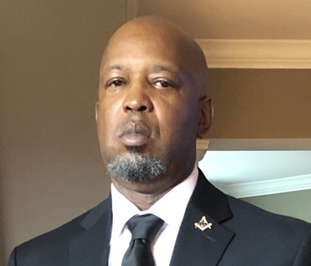
Timothy O. Evans is the Branch Chief for the Border Technologies Contracts Branch, U.S. Customs and Border Protection (CBP), Office of Acquisition (OA), Office of Enterprise Services (ES), Department of Homeland Security (DHS) in Washington, D.C.
Currently, Mr. Evans oversees the Branch’s core mission to procure products, supplies, and services cost effectively and consistent with laws and regulations to support end-user missions. The FY20 spend totaled was an estimated $1.3B.
Before joining CBP, Mr. Evans served as an active duty Marine with a 24 year career in the logistics field, retiring in 2008 as a Major. Mr. Evans served in numerous billets throughout his career and during his last active duty assignment served as the Director of Food Services, Marine Corps Installations East.
Mr. Evans holds a Master of Arts in Computer Resources and Information Management, Business Management, and Procurement and Acquisition Management from Webster University and a Bachelor of Science in Management from Park University.

